Reflection

📘 Definition
# Source: AI Source: Provided by: [Data Path: Persons Table -> ID Column: 1, Name_En Column: Motasem Essam] -> From: [ChatGPT] on [5/2/2026]
Reflection is the process where light hits a surface and bounces back instead of being absorbed. This is what allows us to see objects and also see images in mirrors.

💡 How reflection works
# Source: AI Source: Provided by: [Data Path: Persons Table -> ID Column: 1, Name_En Column: Motasem Essam] -> From: [ChatGPT] on [5/2/2026]
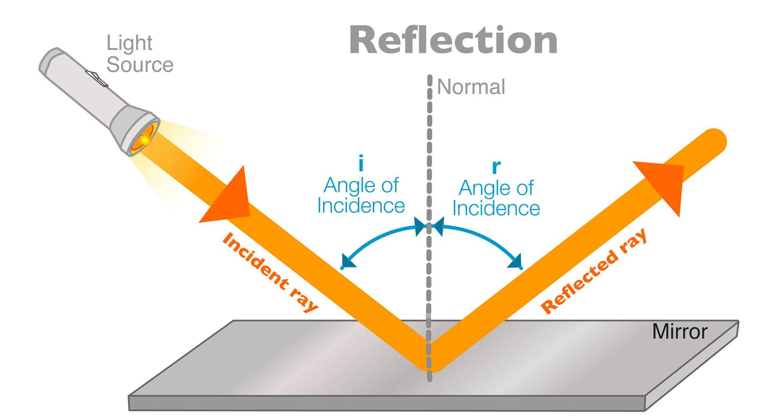
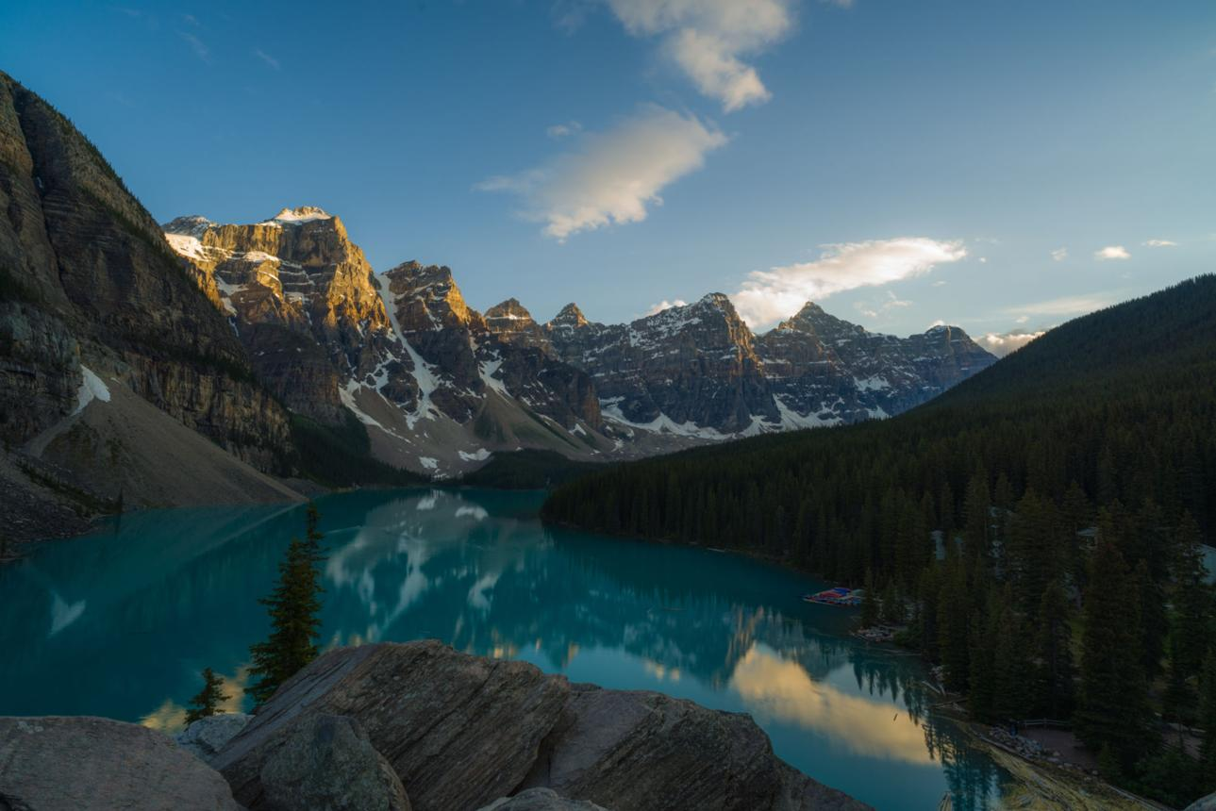
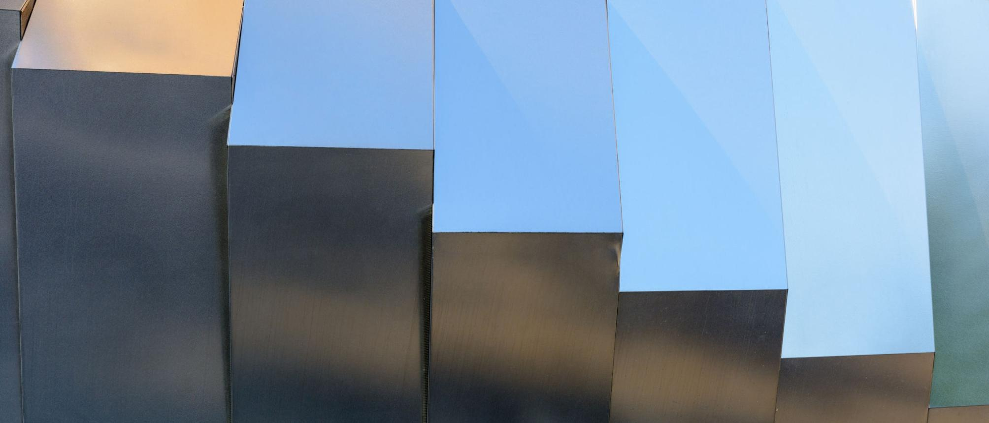
- Light travels in straight lines
- It hits a surface (like a mirror, water, or metal)
- Instead of disappearing, it bounces back
- Our eyes receive this bounced light → we see the object or its image

🧠 Simple example
# Source: AI Source: Provided by: [Data Path: Persons Table -> ID Column: 1, Name_En Column: Motasem Essam] -> From: [ChatGPT] on [5/2/2026]
Think of:
- 🪞 A mirror showing your face → light reflects back to your eyes
- 💧 A lake reflecting the sky
- 🪙 A shiny coin reflecting light

🎮 Reflection in computer graphics
# Source: AI Source: Provided by: [Data Path: Persons Table -> ID Column: 1, Name_En Column: Motasem Essam] -> From: [ChatGPT] on [5/2/2026]
In graphics, reflection is used to:
- Make shiny surfaces look realistic (metal, glass, water)
- Show mirrors and reflective floors
- Improve realism in lighting and materials

⚙️ Key features
# Source: AI Source: Provided by: [Data Path: Persons Table -> ID Column: 1, Name_En Column: Motasem Essam] -> From: [ChatGPT] on [5/2/2026]
- 🔄 Light bounces back from a surface
- 🪞 Works best on smooth, shiny surfaces
- 🎯 Follows the rule: angle of incidence = angle of reflection
- 🌊 Can be sharp (mirror) or blurry (water)

💡 Types of Reflection

1. Specular Reflection (Mirror-like Reflection)
# Source: AI Source: Provided by: [Data Path: Persons Table -> ID Column: 1, Name_En Column: Motasem Essam] -> From: [ChatGPT] on [5/2/2026]
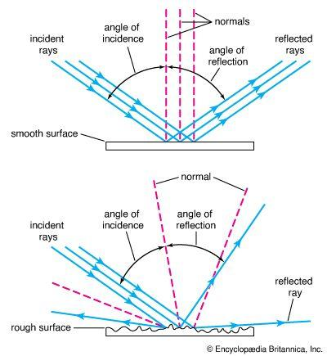
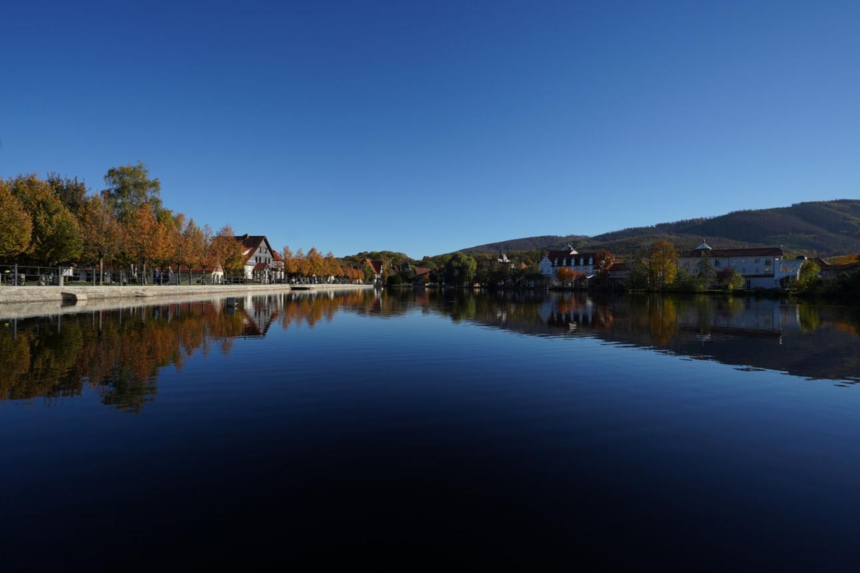
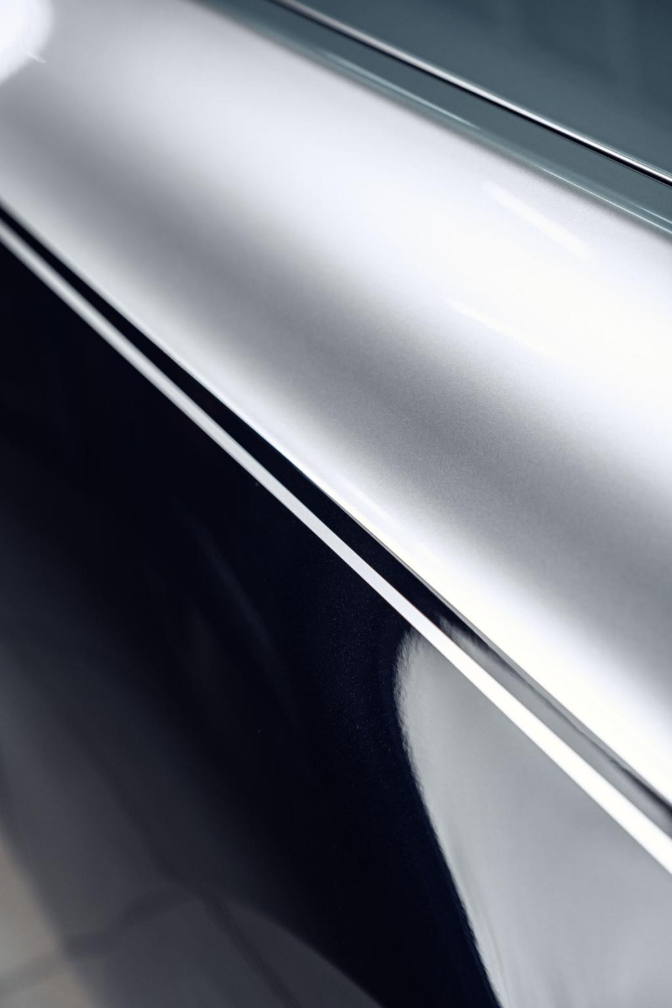
🧠 What it is:
Light reflects in a single, clear direction from a smooth surface.
🎯 Features:
- Sharp and clear reflection
- Happens on smooth surfaces
- Forms mirror-like images
🧑‍💻 Examples:
- Mirror 🪞
- Calm water 💧
- Polished metal 🪙

2. 🌫️ Diffuse Reflection (Scattered Reflection)
# Source: AI Source: Provided by: [Data Path: Persons Table -> ID Column: 1, Name_En Column: Motasem Essam] -> From: [ChatGPT] on [5/2/2026]
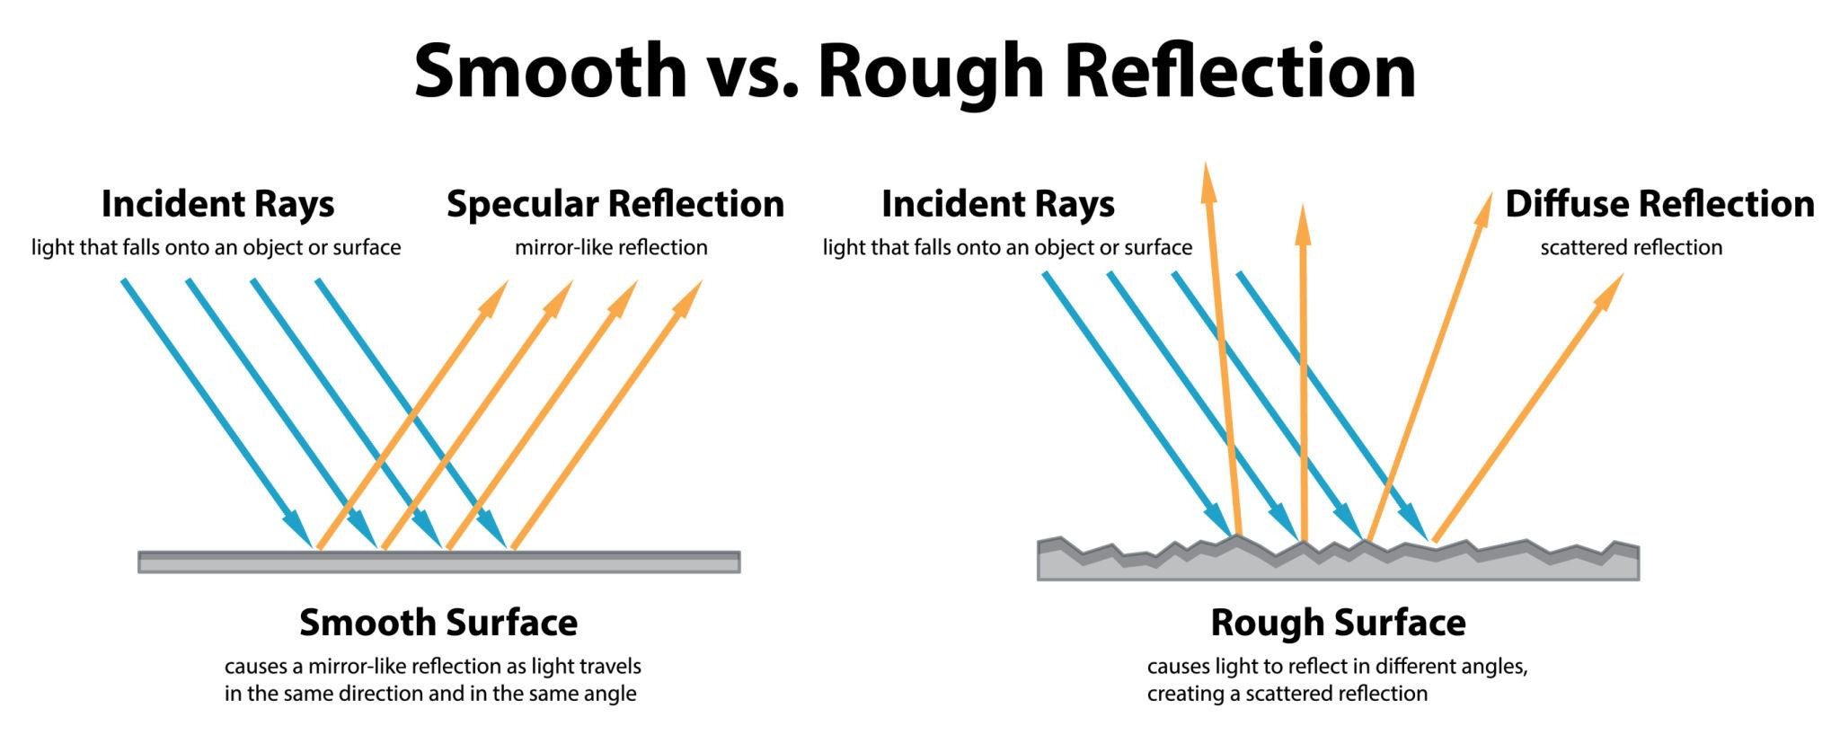
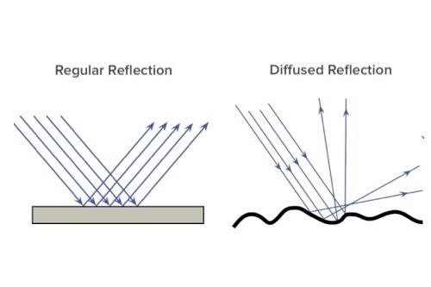
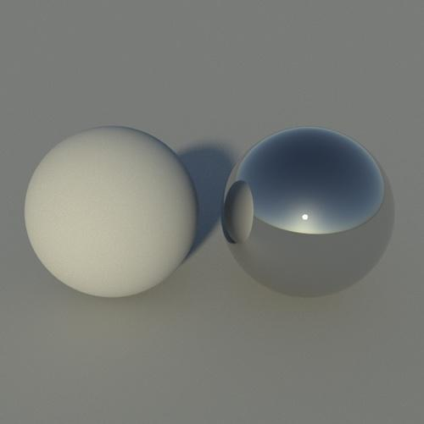
🧠 What it is:
Light reflects in many directions from a rough surface.
🎯 Features:
- No clear image reflection
- Light is scattered
- Makes objects visible from all angles
🧑‍💻 Examples:
- Paper 📄
- Walls 🧱
- Clothing 👕

🧠 Simple difference
# Source: AI Source: Provided by: [Data Path: Persons Table -> ID Column: 1, Name_En Column: Motasem Essam] -> From: [ChatGPT] on [5/2/2026]
- 🪞 Specular Reflection → clear mirror-like reflection
- 🌫️ Diffuse Reflection → scattered, no clear image

🚀 In short:
# Source: AI Source: Provided by: [Data Path: Persons Table -> ID Column: 1, Name_En Column: Motasem Essam] -> From: [ChatGPT] on [5/2/2026]
Reflection = when light hits a surface and bounces back, allowing us to see objects or their images.

